**6.3 Project Worksheet: Using Windows System Tools**

|  |  |  |  |
| --- | --- | --- | --- |
| **#** | **Item** | **Tool Used** | **Answer** |
| 1 | OS Version being run | System Information | Microsoft windows 11 version 10.0.22621 |
| 2 | Primary Boot Device | System Information | \Device\HarddiskVolume1 |
| 3 | Physical Memory Installed | System Information | 8.00 GB |
| 4 | Volume Serial Number of Hard Drive | System Information | 68E84F7C |
| 5 | IP Address of Computer | Command Prompt | 192.168.12.175 |
| 6 | Primary DNS Server | Command Prompt | Intel(R) Dual Band Wireless-AC 8260 8.34.34.34 |
| 7 | Memory being used (will change) | System Information | 7.88 GB |
| 8 | Current user | System Information | Randisoft\randa |
| 9 | Is the Bluetooth User Service currently running? | Windows Settings | Yes |
| 10 | Is Cortana enabled at startup? | Windows Settings | No |
| 11 | What is the CPU Score using the Windows Experience Index? You may need to research this online. | Command Prompt | 8.5 |
| 12 | When was Windows Update last checked? | Windows Settings | 12:07PM March 4, 2023 |
| 13 | Does your PC meet requirements for Windows 11? If running Windows 11 answer Yes! | Windows | Yes |
| 14 | What is the status of your Firewalls? | Control Panel | Active(on) |
| 15 | What is your current theme? | Windows Settings | Custom |
| 16 | What is your default printer? | Windows Settings | Managed by windows |
| 17 | What is the IP address of www.ksl.com | Command Prompt | 64.147.131.201 |
| 18 | How many hops does it take to get from your computer to www.ensign.com? | Command Prompt | 14 |
| 19 | How much disk space is currently used for system protection? If system protection is not enabled, you might want to enable it! | Control Panel | 82%(193.75GB) |
| 20 | Is remote desktop enabled? | Windows Setting | No |

21. Open your Event Viewer and submit a screenshot of the Summary of Administrative Events. Below the screenshot, list the last Error encountered by your PC.

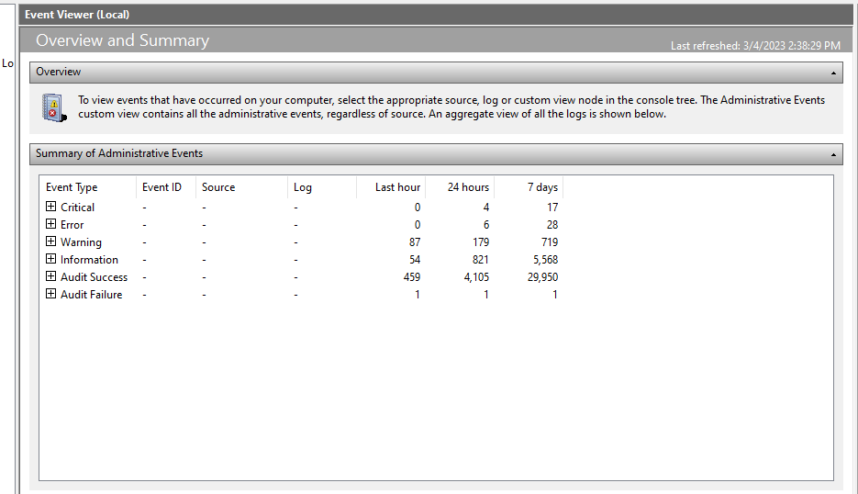

The last error encountered by the system is Kernel-boot

22. You wish to review your computer’s reliability and problem history. Open the appropriate tool and submit a screenshot. Below the screenshot list the last Application failure.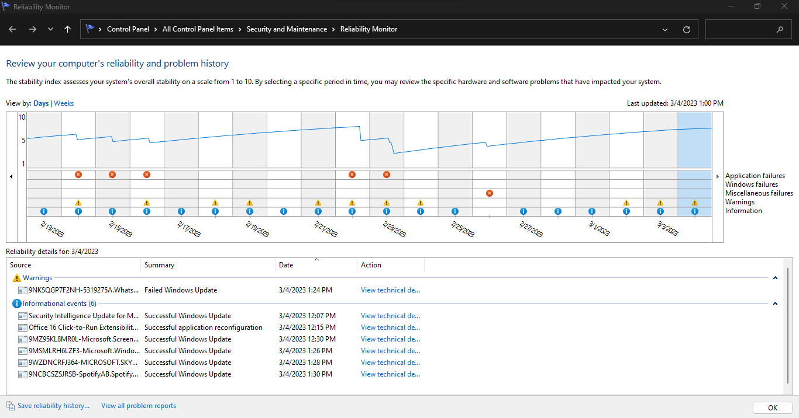

Runtime Broker stopped working.

23. Open Local Users and Groups using the appropriate tool. Submit a screenshot of the current users on your computer.

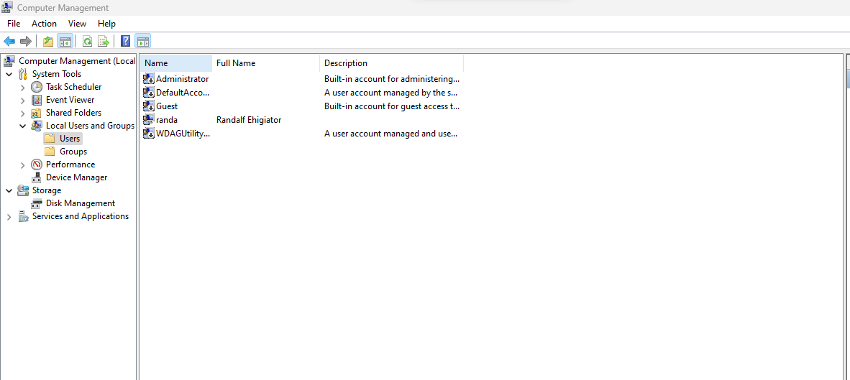

24. You want to view the partitions on your C: drive. Use the appropriate tool and submit a screenshot of the partition data for your drive.

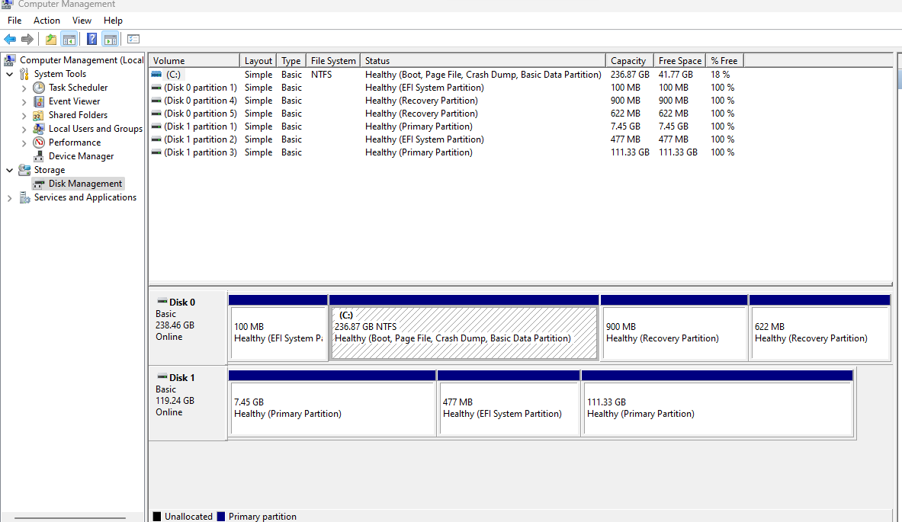

25. You need to find out whether File and Printer Sharing is being blocked by your Firewall. Using the appropriate tool and submit a screenshot showing the status of File and Printer Sharing.

